chinese hacker

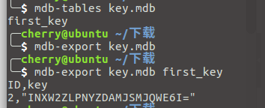

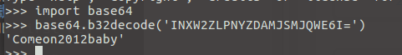

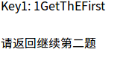



mdbtools 用法：http://www.2cto.com/kf/201707/660436.html

1GetThEFirst+2tHEWinNer